Giuliano Cancilla

Final Project Explanation

8/7/2024

How to setup Unreal Engine for Python Scripting

I followed this pretty easy guide to setting it up. All you have to do is enable the plugin and then you can go to tools and at the very bottom it gives you the option to run a python script. Click that and choose my script “Final.py”.

Guide: <https://dev.epicgames.com/documentation/en-us/unreal-engine/scripting-the-unreal-editor-using-python>

Enabling Playability

I have commented out the custom assets that I used for some of the creation like the glasswalls and the flag, but I made it so everything that you need is in the starter pack that comes pre-loaded.

Playing the game may not work at the start of the new project. If you want it to be playable you have to go to the content browser (file paths at the bottom of the screen should just be opened).

Step 1: Go to content Browser (this is the file path system of Unreal)

Step 2: Click Add

Step 3: Click “Add feature or Content Pack”

Step 4: You can choose third person or first person, first person is fun because it shows you the scale of everything

Step 5: At the top Left of Unreal Engine (Not the content brower) go to Edit- > Project Settings

Step 6: Go to Maps and Modes on the left panel (4th down in project)

Step 7: Go to default game Mode (if you choose first person the option is BP_FirstPersonGameMode)

Step 8: Restart Unreal Engine (You may not have to do this but I did to get it to work or else it was a black screen)

To Run Script:

Start a new project, I chose the landscape project and make sure you have the StarterContent under the content browser. Then go to Tools -> Execute Python Script and then choose the script.

Screenshots

10x10

.

20x20

20x20


35x35

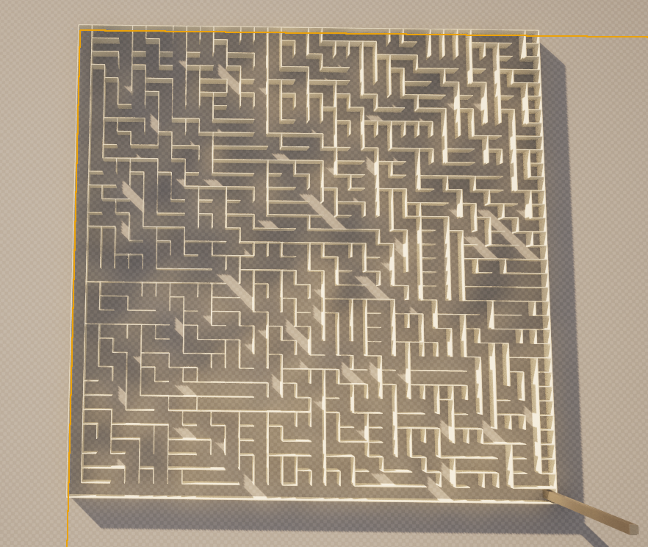

50x50

